EXP 6
HARISARAN A
240701170
Execution of Deluge Functions in Zoho Creator

Aim
To create and execute Deluge functions in Zoho Creator for performing various operations in the Vehicle Service application and to verify their outputs.

Procedure
- Open the Vehicle Service application in Zoho Creator.
- Navigate to Workflows → Functions.
- Click New Function.
- Enter the required Function Name.
- Select the appropriate Return Type.
- Add the required Arguments with their data types.
- Click Create to open the Deluge editor.
- Enter the required Deluge script.
- Click Save to save the function.
- Click Execute and provide the required input values.
- Click Submit/Execute and observe the output.
- Verify that the obtained output is correct.

Output
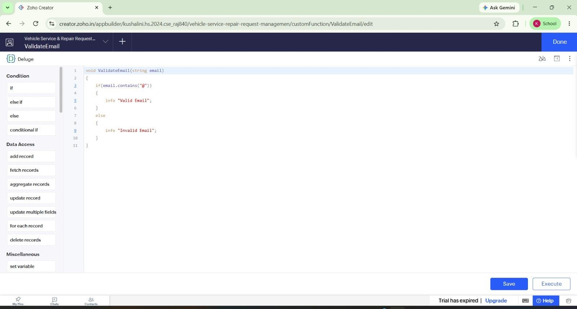
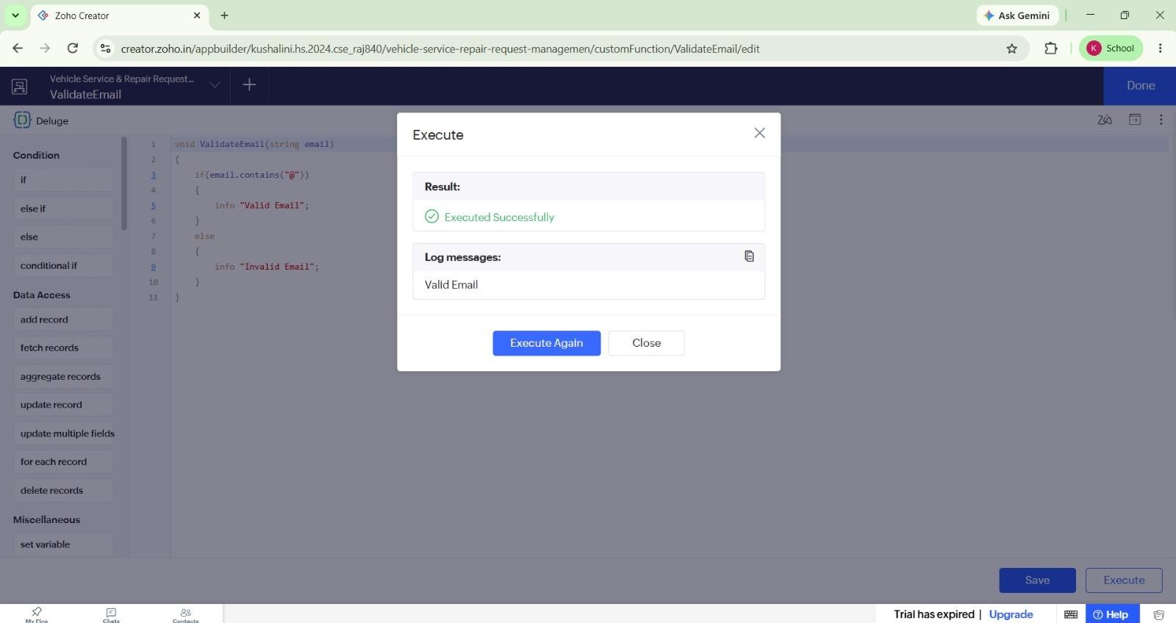

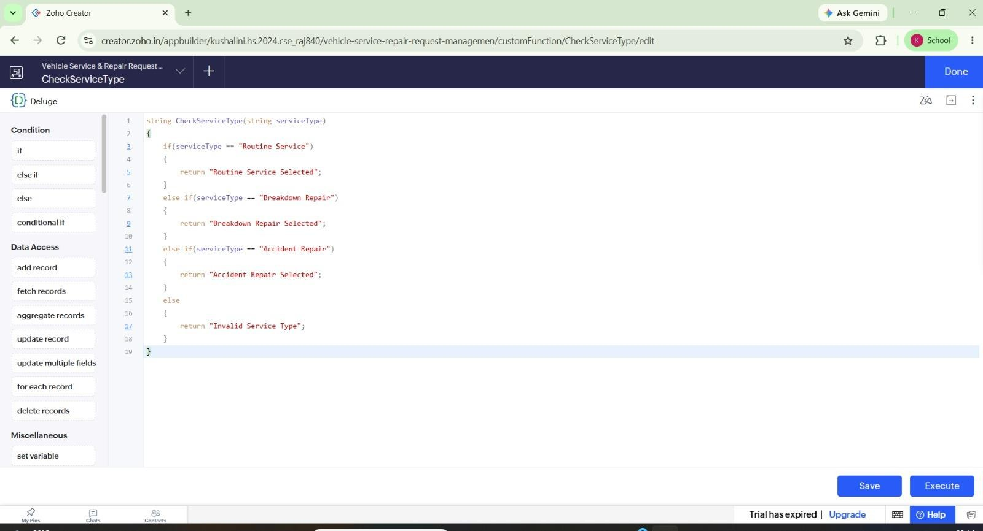
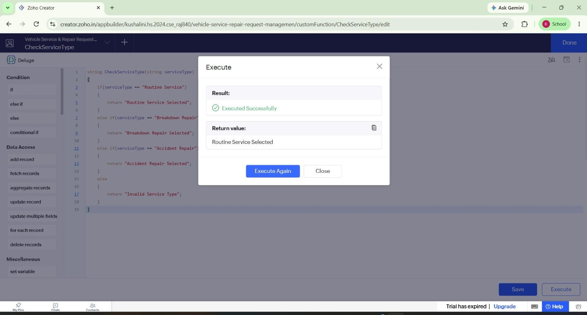
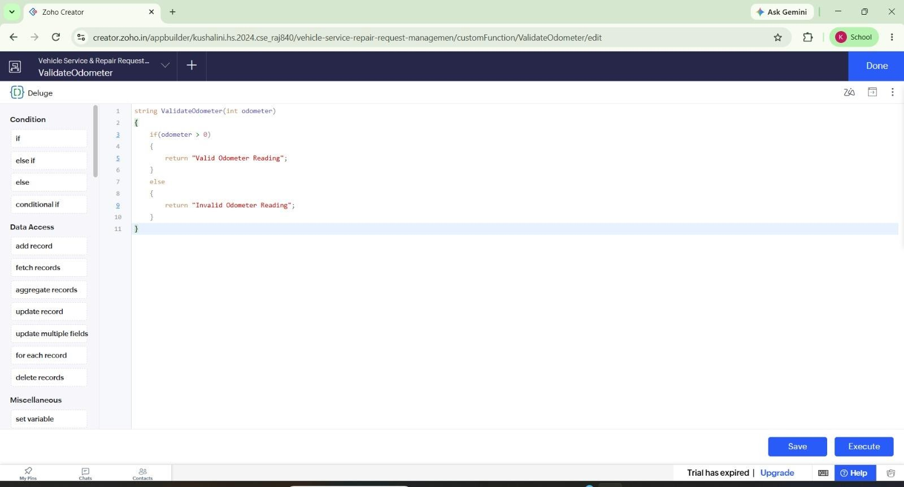
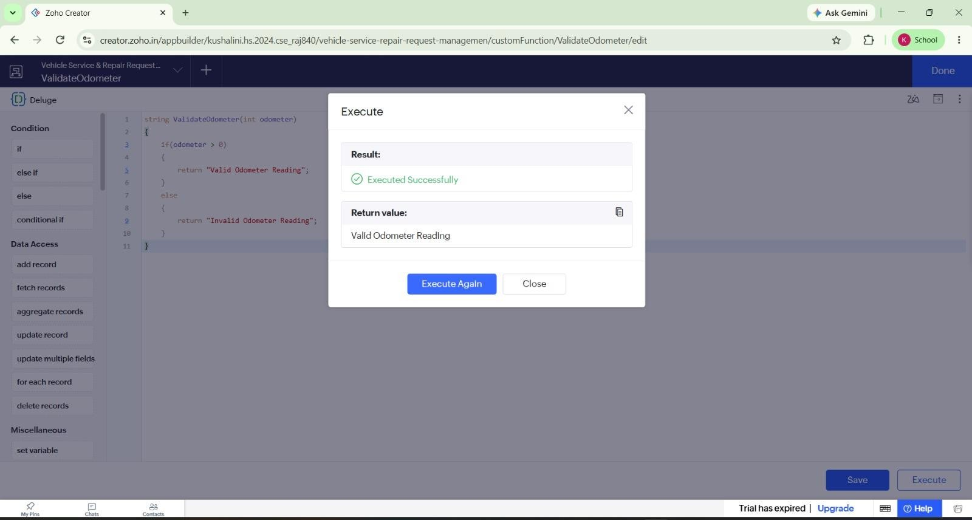
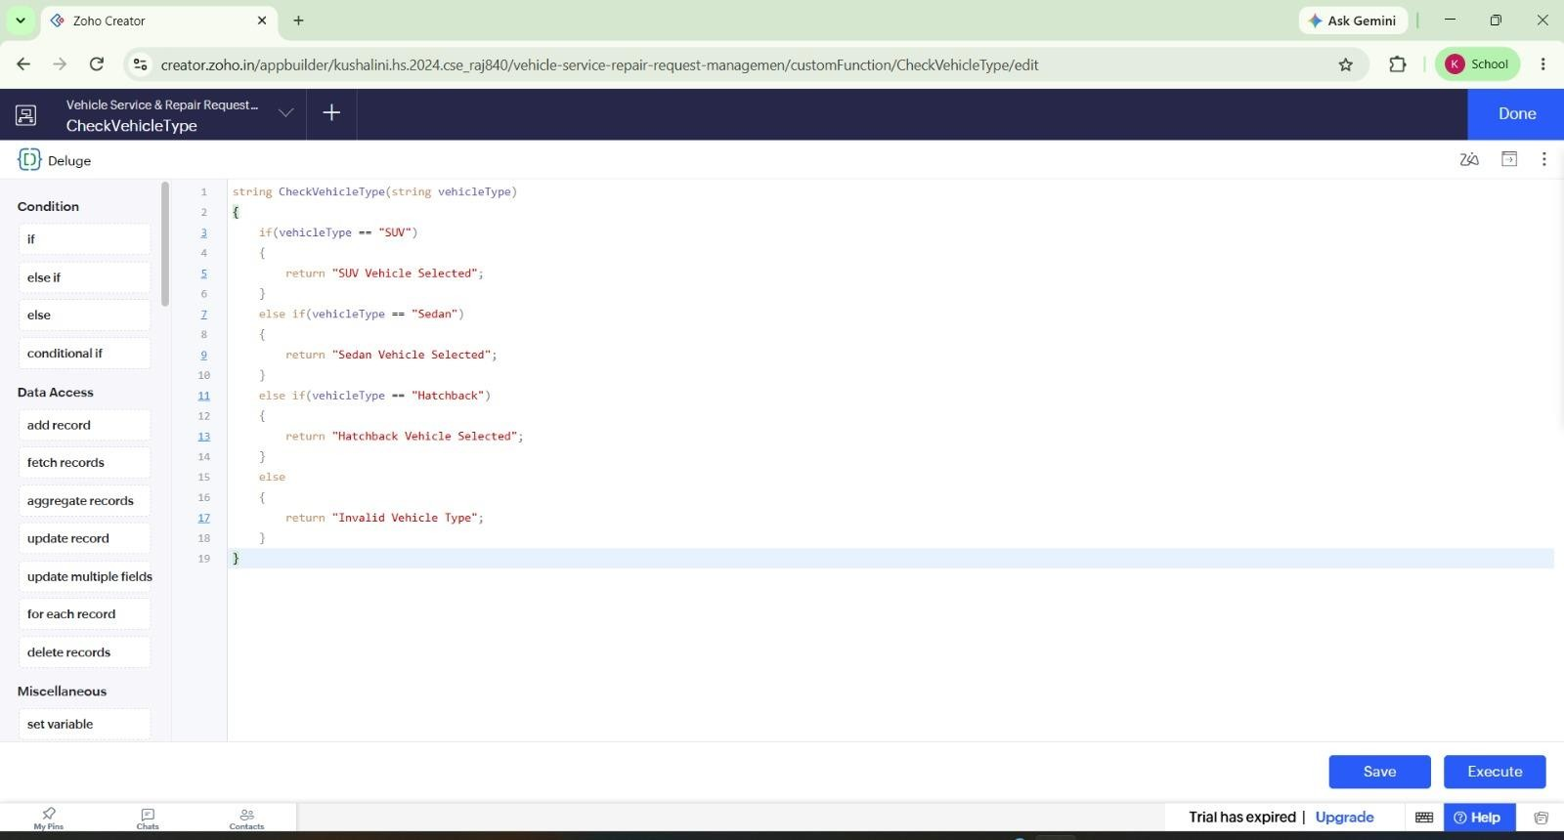
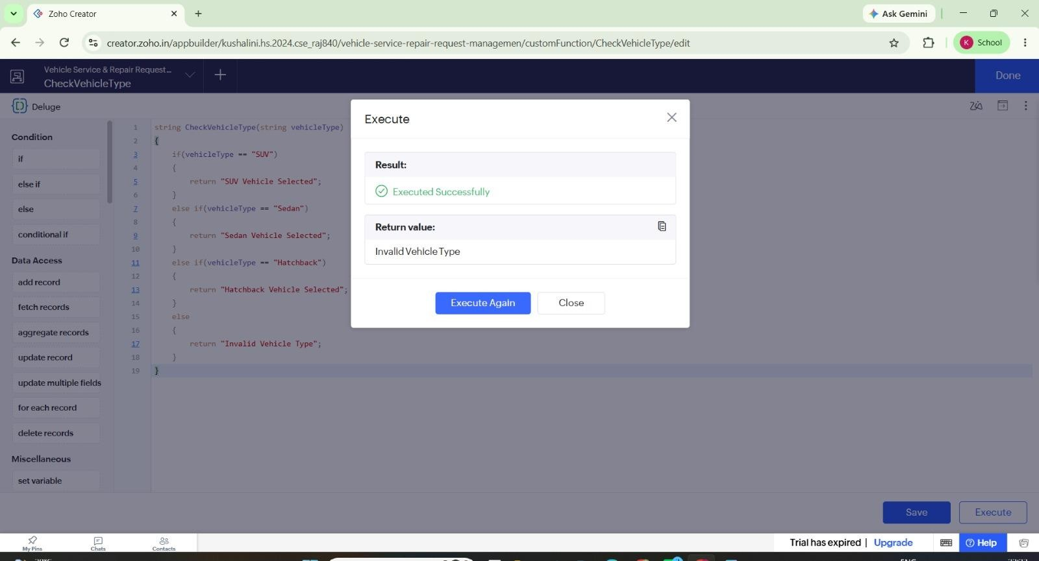
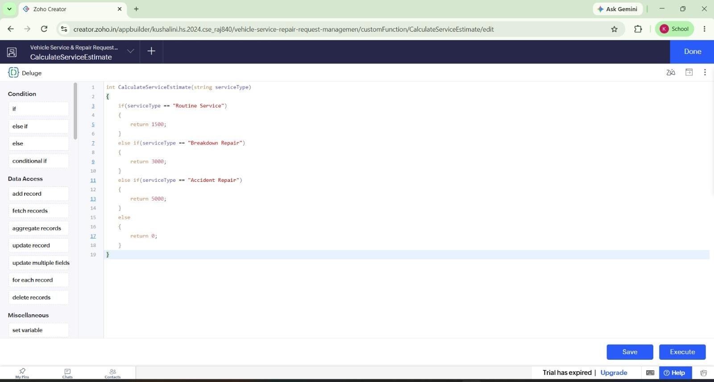
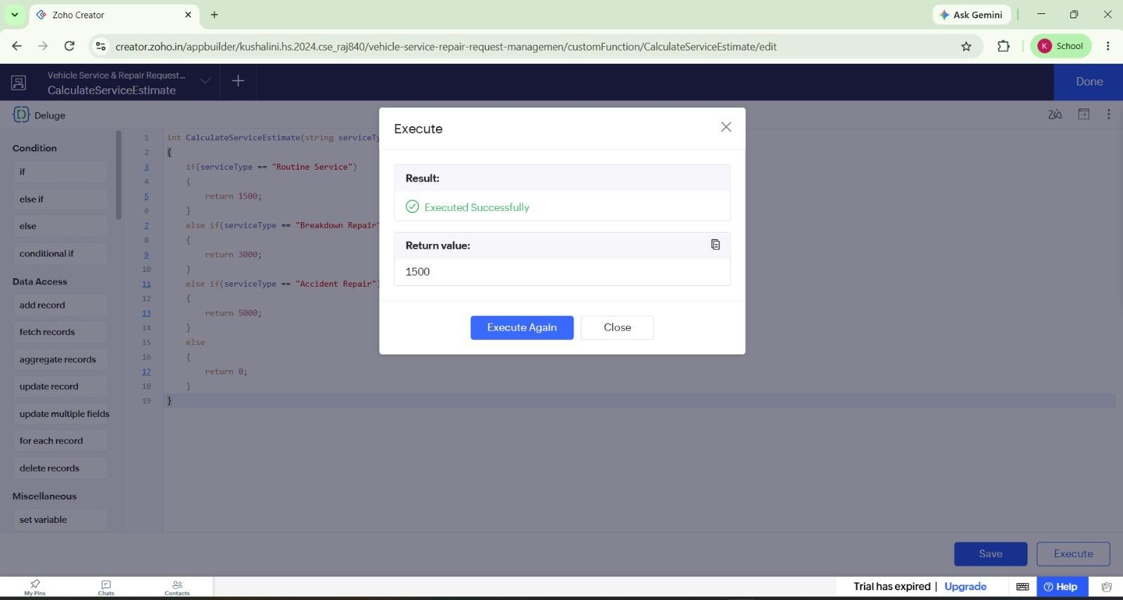
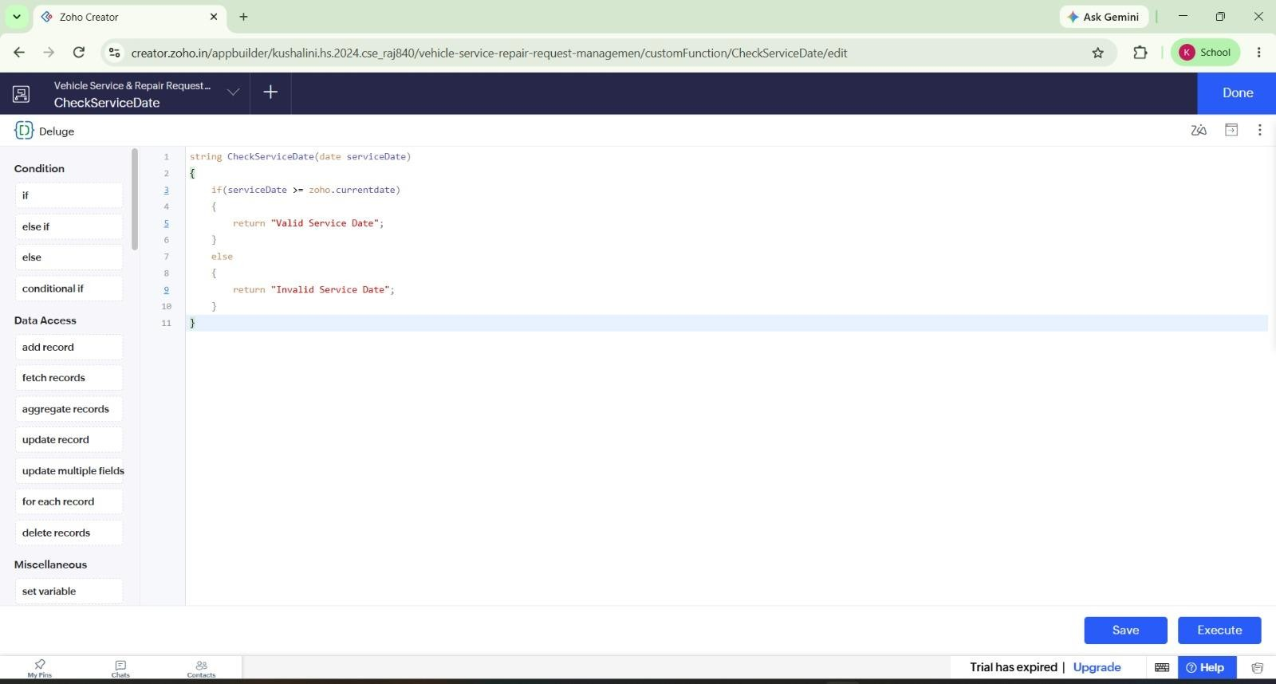
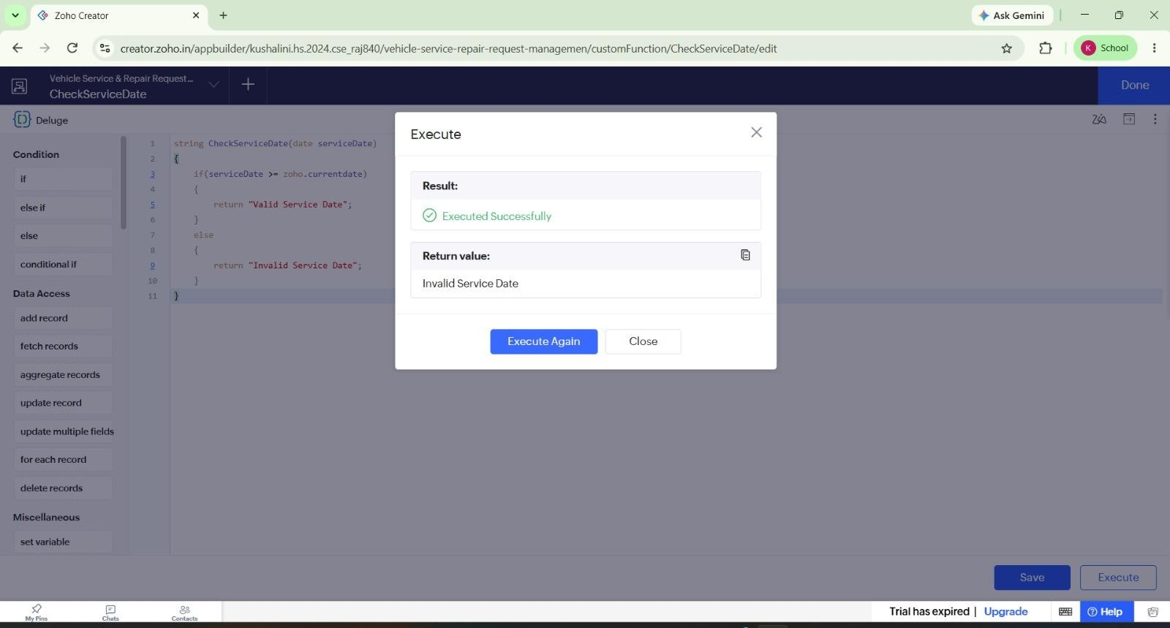
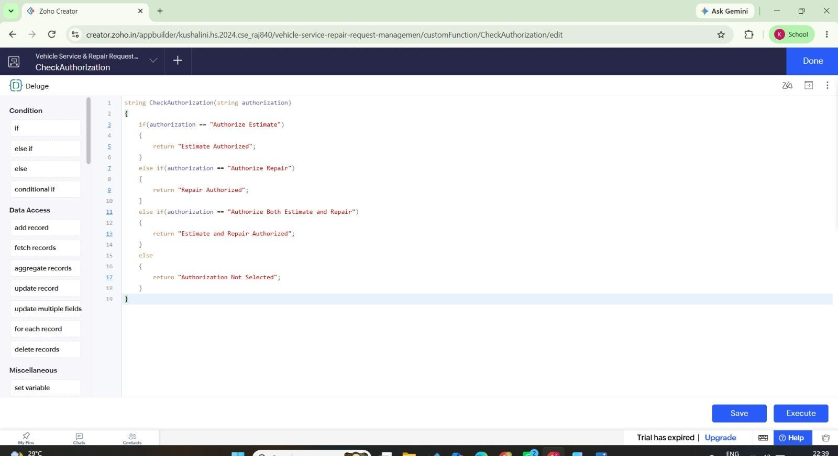
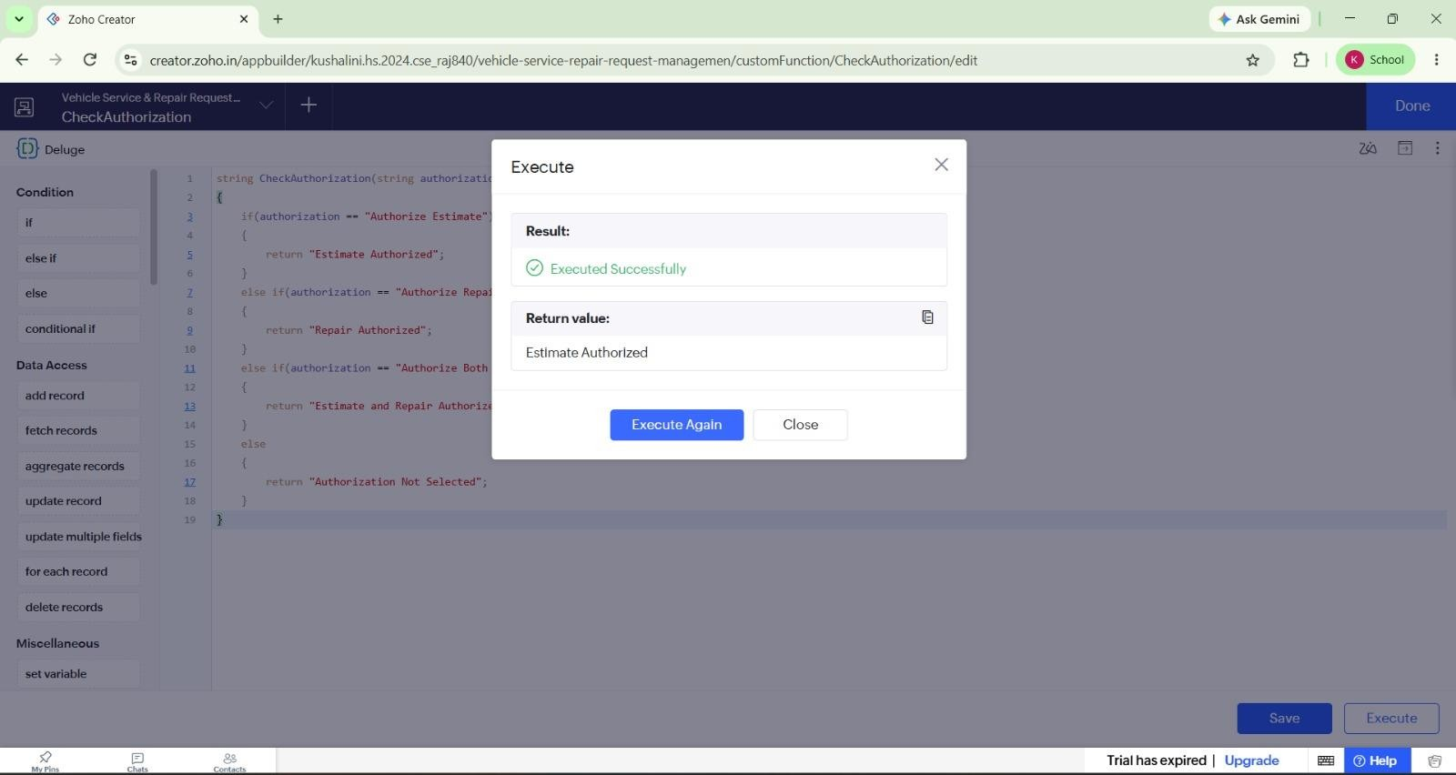
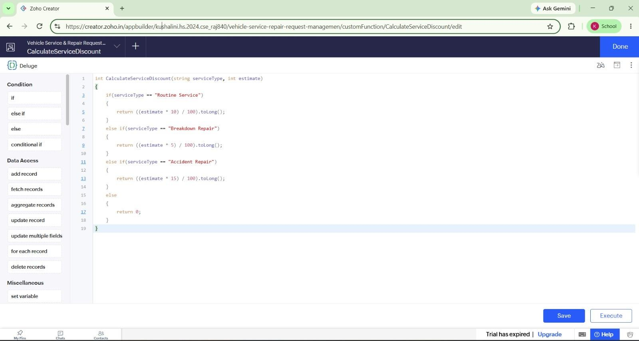
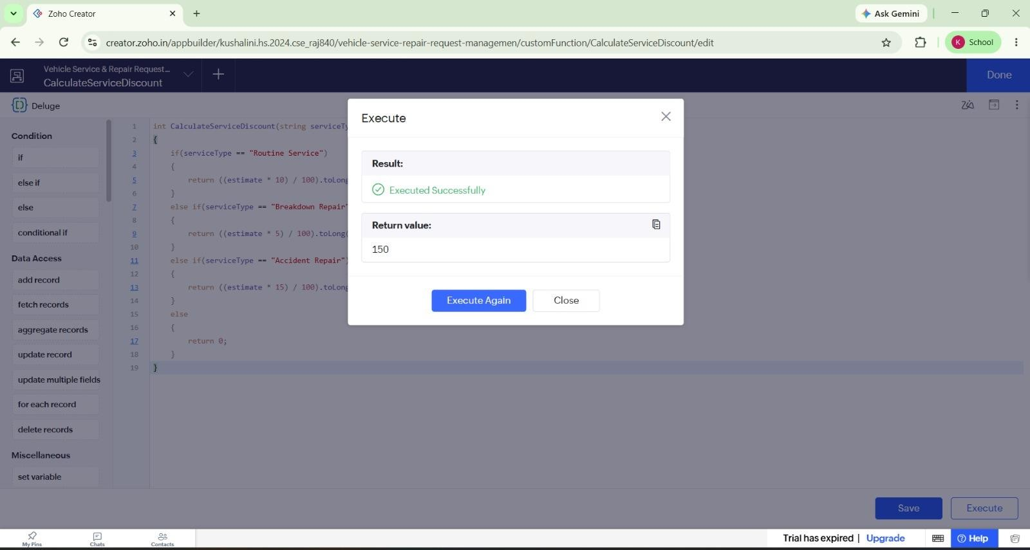
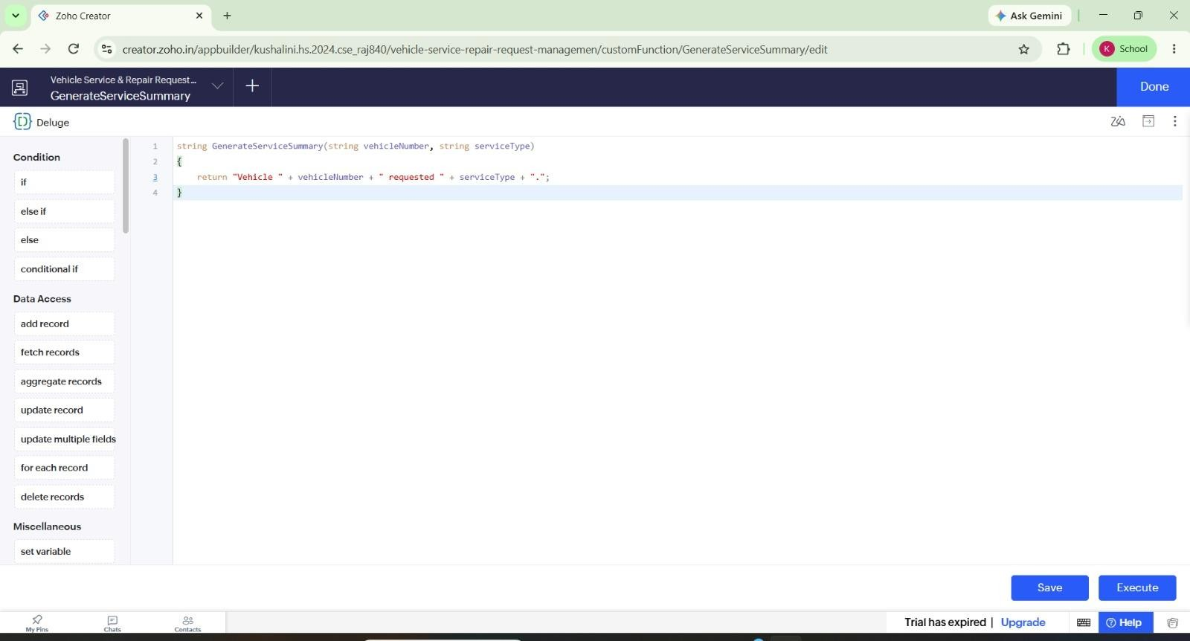
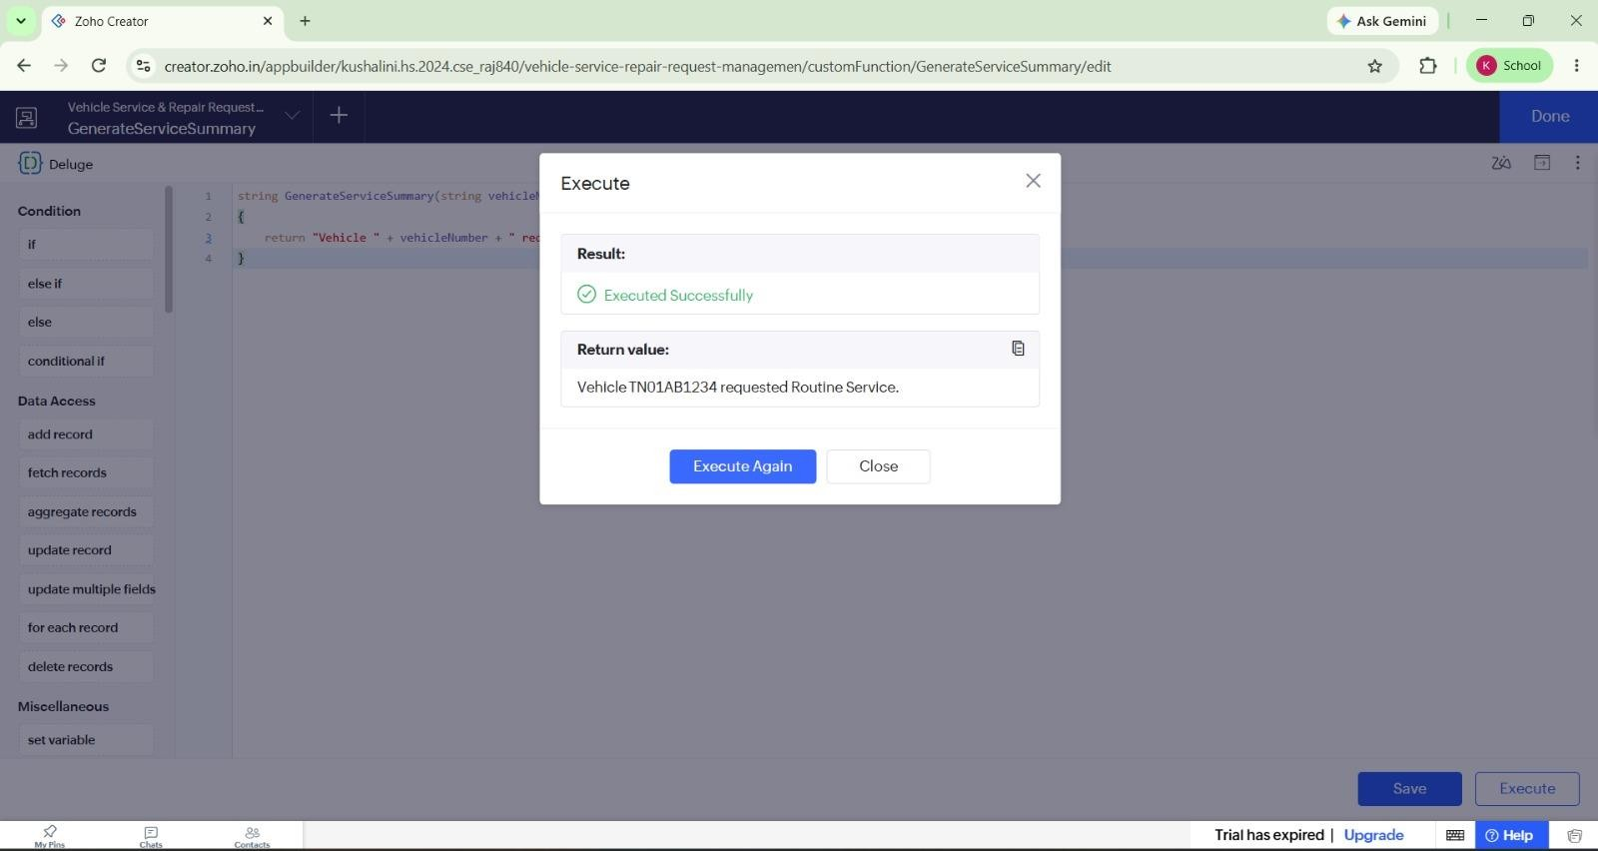
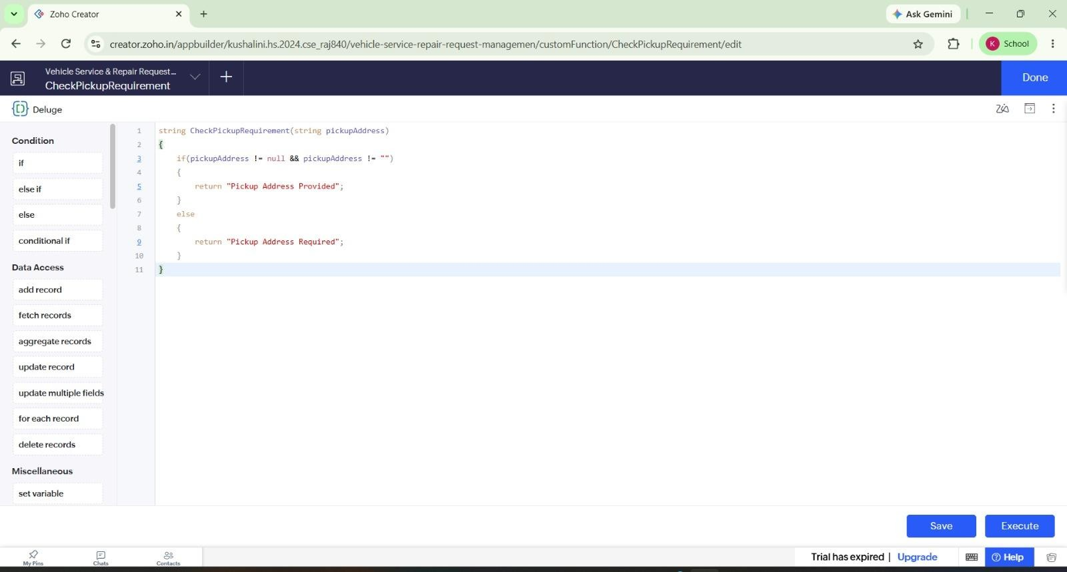
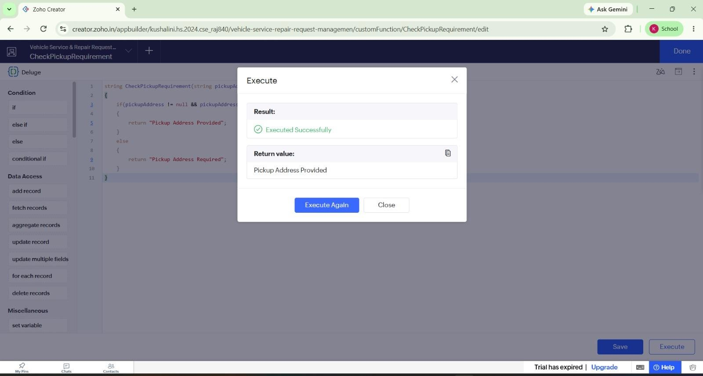

Result
Thus, the Deluge functions were successfully created, executed, and verified in Zoho Creator for the Vehicle Service application.

